Project Design Phase
Problem – Solution Fit Template

Date | 15 February 2025
Team ID | LTVIP2026TMIDS65560
Project Name | Educational Organization Using ServiceNow
Maximum Marks | 2 Marks

Problem – Solution Fit Template:
The Problem-Solution Fit simply means that you have found a problem with your customer and that the solution you have realized for it actually solves the customer’s problem. It helps entrepreneurs, marketers and corporate innovators identify behavioral patterns and recognize what would work and why
Purpose:
- Solve complex problems in a way that fits the state of your customers.
- Succeed faster and increase your solution adoption by tapping into existing mediums and channels of behavior.
- Sharpen your communication and marketing strategy with the right triggers and messaging.
- Increase touch-points with your company by finding the right problem-behavior fit and building trust by solving frequent annoyances, or urgent or costly problems. • Understand the existing situation in order to improve it for your target group.

Template:
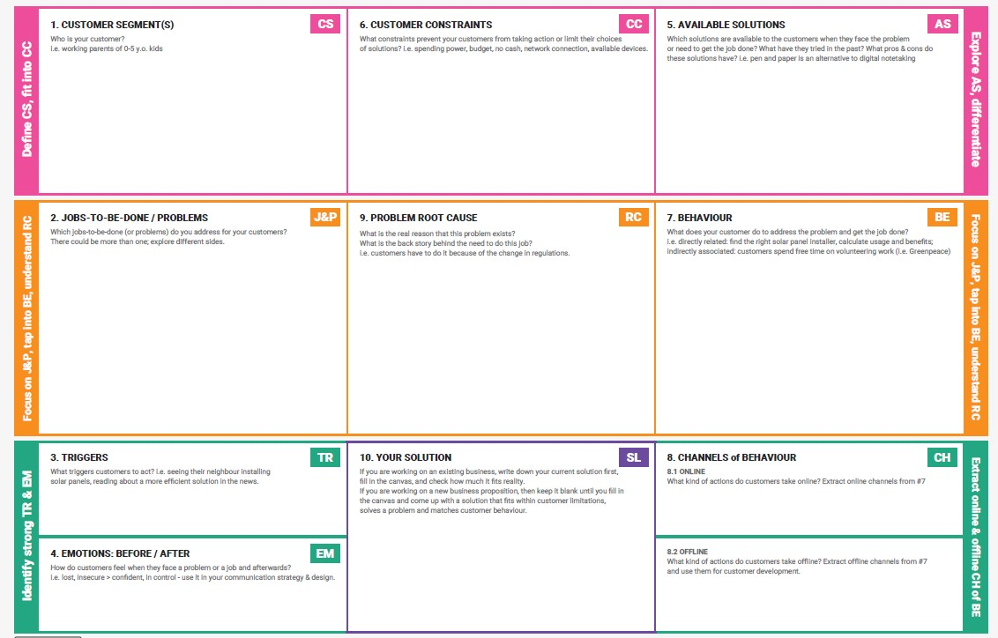

Target Customers / Users
- Students
- Teachers
- Administrative Staff

Problems Identified
- Manual handling of student records and academic data.
- Delay in service request processing.
- Lack of centralized academic management system.
- Poor communication between students and administration.

Customer Needs
- Easy access to academic information.
- Fast request handling system.
- Secure data management.
- Real-time updates and notifications.

Proposed Solution
A centralized cloud-based educational management system that automates student records, course management, service requests, and communication using ServiceNow platform.

Value / Benefits
- Reduces manual work.
- Improves efficiency.
- Faster service delivery.
- Better communication and data security.

References:
- https://www.ideahackers.network/problem-solution-fit-canvas/
- https://medium.com/@epicantus/problem-solution-fit-canvas-aa3dd59cb4fe

